

With this series, break down the 5 love languages each week and how we see them displayed in the Bible.

Suggested Schedule

-Intro
- Lead in prayer
- Rules
- Game
- Memory Verse
- Offering
-Praise and Worship
-Teaching Time
- Sword Drill (Have students find Bible Story in their Bibles)
- Kids Theater (Have students act out Bible Story)
- Minister Moment (Teacher talks about practical application and nugget of inspiration)
- Alter call
- Small Groups


Memory Verse
John 15:12
My command is this: Love each other as I have loved you.

Bible lesson: Judges 6:11-18, 7:1-25

Main Focus: Gideon was encouraged and empowered to do what God commanded him to do.

Minister Moment: Wrap up Bible story and give kids a nugget of inspiration, we need to build each other up with kind words.

With this series, break down the 5 love languages each week and how we see them displayed in the Bible.

Suggested Schedule

-Intro
- Lead in prayer
- Rules
- Game
- Memory Verse
- Offering
-Praise and Worship
-Teaching Time
- Sword Drill (Have students find Bible Story in their Bibles)
- Kids Theater (Have students act out Bible Story)
- Minister Moment (Teacher talks about practical application and nugget of inspiration)
- Alter call
- Small Groups


Memory Verse
John 15:12
My command is this: Love each other as I have loved you.

Bible lesson: John 3:16 Have kids or leaders act out Jesus taking on all our sin at the cross (use chains or something bulky/heavy to a kid)

Main Focus: God gave us the ultimate gift with Jesus

Minister Moment: take time to do salvation alter call

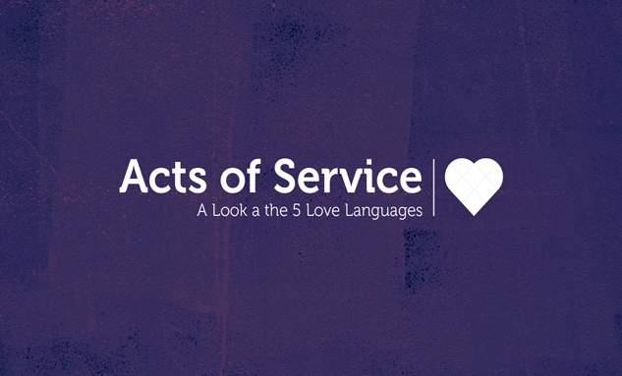

With this series, break down the 5 love languages each week and how we see them displayed in the Bible.

Suggested Schedule

-Intro
- Lead in prayer
- Rules
- Game
- Memory Verse
- Offering
-Praise and Worship
-Teaching Time
- Sword Drill (Have students find Bible Story in their Bibles)
- Kids Theater (Have students act out Bible Story)
- Minister Moment (Teacher talks about practical application and nugget of inspiration)
- Alter call
- Small Groups

Memory Verse
John 15:12
My command is this: Love each other as I have loved you.

Bible lesson: John 13:1-17

Main Point: Jesus displayed a servant’s heart and teaches the disciples about serving others.

Minister Moment: We can show love when we put others before ourselves and serve them.


With this series, break down the 5 love languages each week and how we see them displayed in the Bible.

Suggested Schedule

-Intro
- Lead in prayer
- Rules
- Game
- Memory Verse
- Offering
-Praise and Worship
-Teaching Time
- Sword Drill (Have students find Bible Story in their Bibles)
- Kids Theater (Have students act out Bible Story)
- Minister Moment (Teacher talks about practical application and nugget of inspiration)
- Alter call
- Small Groups

Memory Verse
John 15:12
My command is this: Love each other as I have loved you.

Bible lesson: Luke 10:38-42

Main Point: Sometimes we just need to stop, listen and spend time with God.

Minister Moment: We can do so many things for Him and to serve Him, but we also need to rest and be in His presence.

With this series, break down the 5 love languages each week and how we see them displayed in the Bible.

Suggested Schedule

-Intro
- Lead in prayer
- Rules
- Game
- Memory Verse
- Offering
-Praise and Worship
-Teaching Time
- Sword Drill (Have students find Bible Story in their Bibles)
- Kids Theater (Have students act out Bible Story)
- Minister Moment (Teacher talks about practical application and nugget of inspiration)
- Alter call
- Small Groups

Memory Verse

John 15:12
My command is this: Love each other as I have loved you.

Bible lesson: John 9:1-12

Main Point: There is healing power when we lay hands on the sick.

Minister Moment: have the kids put what they learned into practice, and lay hands and pray over each other.

